CardKeep User Manual
Version 0.6.2 · Android · October 2026
CardKeep turns the business cards you collect into contacts on your phone. You photograph a card; CardKeep
straightens it, reads it on the phone, fills in the contact and keeps the card with the person. There is no
account and no cloud: everything stays in CardKeep's private storage on your phone.

I want to...
I want to... | Go to
Scan one card | Scanning cards → One card
Scan a stack quickly | Scanning cards → Batch and Pile
Fix something the scanner got wrong | Reviewing a scan
Find someone | Contacts → Search and filters
Remember to follow up | Follow-ups and reminders
Group people from a trade show | Events
Tag customers or suppliers | Tags
Merge two copies of one person | Duplicates
See who changed jobs | Career moves
Read an NFC business card | Tap cards (NFC)
Share my own details | My card
Move contacts in or out | Import, Export
Keep a copy of everything | Backup and restore
Change the look | Settings → Appearance
Get the newest version | Settings → Updates

1. Getting around
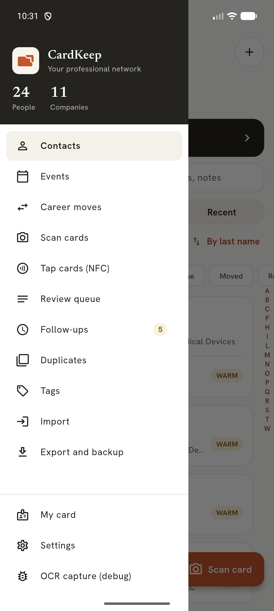
The side menu
Open the menu with the round button at the top left of Contacts. Every area of CardKeep is listed there:
Contacts, Events, Career moves, Scan cards, Tap cards (NFC), Review queue, Follow-ups, Duplicates, Tags, Import,
Export and backup, My card and Settings. The menu header shows how many people and companies you have.
Back from any area returns to Contacts; Back from Contacts leaves the app.
The + button at the top right of Contacts offers: Scan a card, Scan a stack, Add by hand, Import card photos and
Tap an NFC card. The orange Scan card button at the bottom opens the scanner directly.

2. Scanning cards
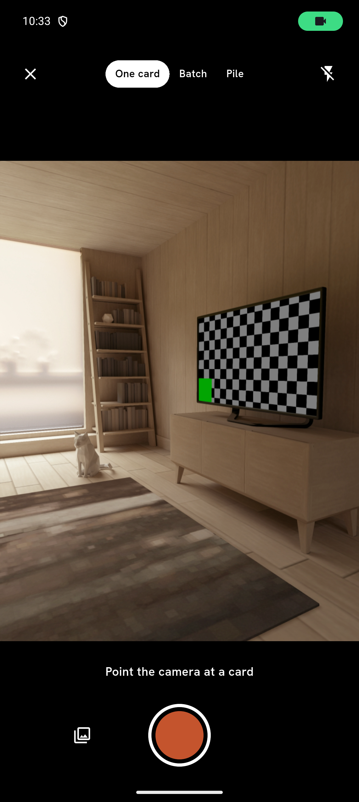
The scanner
The first time, Android asks to let CardKeep use the camera. Choose While using the app. Without the camera you
can still pick card photos from the gallery.

One card
- Tap Scan card.
- Hold the card flat in view, filling about half the width. CardKeep draws its outline and gives one hint at a time:
*Move closer*, *Hold steady*, *Glare, tilt the card*, *More light*.
- When the card is sharp and steady it captures by itself. You can also press the shutter.
- The card is straightened and read. Each detail it finds lights up with a label (Name, Title, Company, Phone,
Email...).
Top bar: × closes the scanner; the lightning button turns the torch on. Tap the preview to focus.
The gallery button (bottom left) picks card photos instead of taking one.

Batch and Pile
- Batch: keep shooting cards one after another. Each is read in the background while you shoot the next.
Clear cards go straight to Contacts (Settings → *Save clear cards automatically*, on by default); the rest wait
in the Review queue.
- Pile: lay several cards on a table and take one photo. Each card is found, straightened and listed.
Every capture is stored on the phone before it is read, so closing the app mid-scan loses nothing: the cards are
read the next time you open CardKeep ("Reading 2 cards left from last time"). A photo that fails to read three times
is set aside and you are told once.

QR codes on cards
A contact QR fills the form exactly and wins over the printed text; where they disagree the field is marked
amber. A web-link QR shows its real address, warns about link shorteners, look-alike characters and non-https
links, and opens only when you tap it.

3. Reviewing a scan
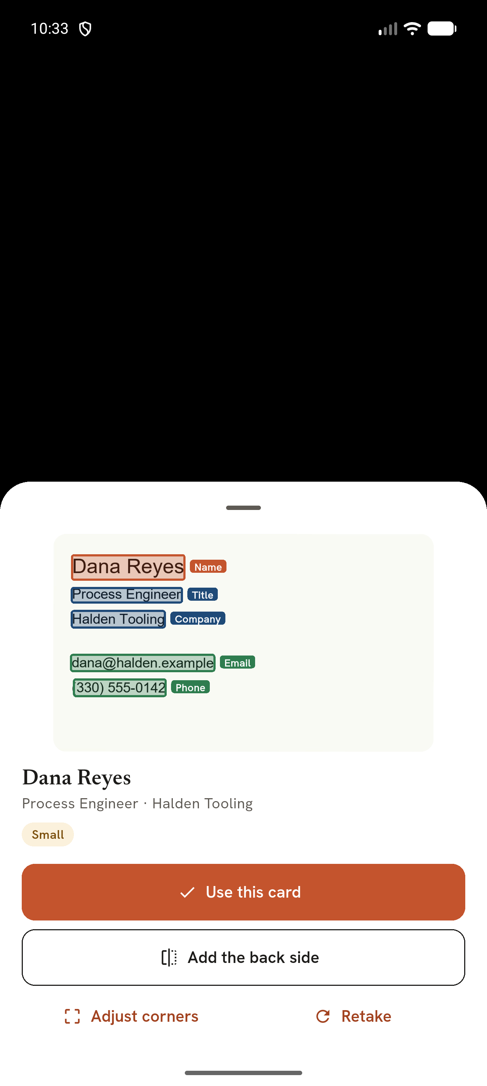
Reviewing a scanned card
After a capture you see the card with every detail it found.
- Use this card opens the new-contact form, filled in. Fields the reader was unsure of are amber: check them.
- Add the back side photographs the back; its details fill gaps the front left.
- Adjust corners lets you drag the card's corners (with a magnifier) when the edges were not found.
- Retake discards this photo.
On the review screen, tap any line of text on the card and choose which field it belongs to, or use **Read a
region** to draw a box and read just that part.
Names printed in capitals are re-cased ("FRED PANETO" → "Fred Paneto", keeping McDonald, O'Brien). Phone extensions
("Ext. 112") are kept with the number; fax numbers are kept as their own line and never dialled. Licence numbers,
opening hours and social handles are sorted into labelled lines. A company logo cut from the card becomes the
contact's picture.
Before saving, CardKeep checks for a possible duplicate and a job change (same person, new company).

Review queue
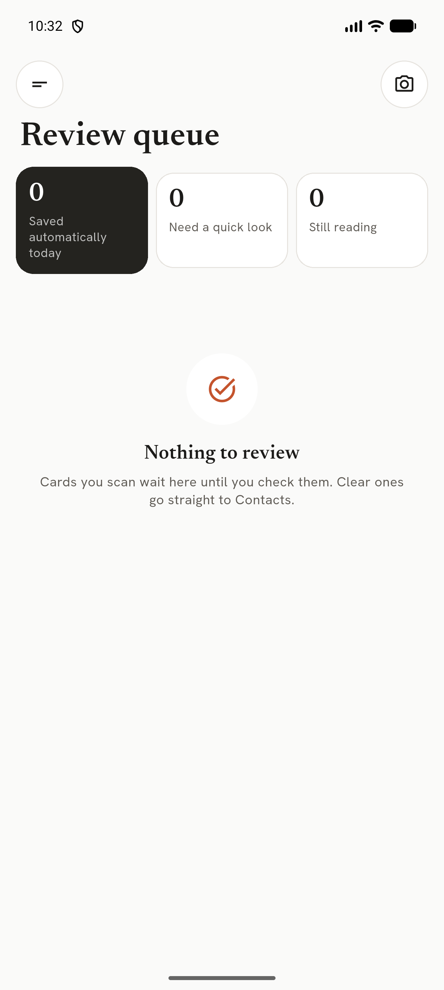
Review queue
Menu → Review queue lists cards waiting for you, with counts for cards saved automatically today, cards that need
a quick look, and cards still being read. Tap a card to review it; swipe it away to remove it (with Undo).

4. Contacts
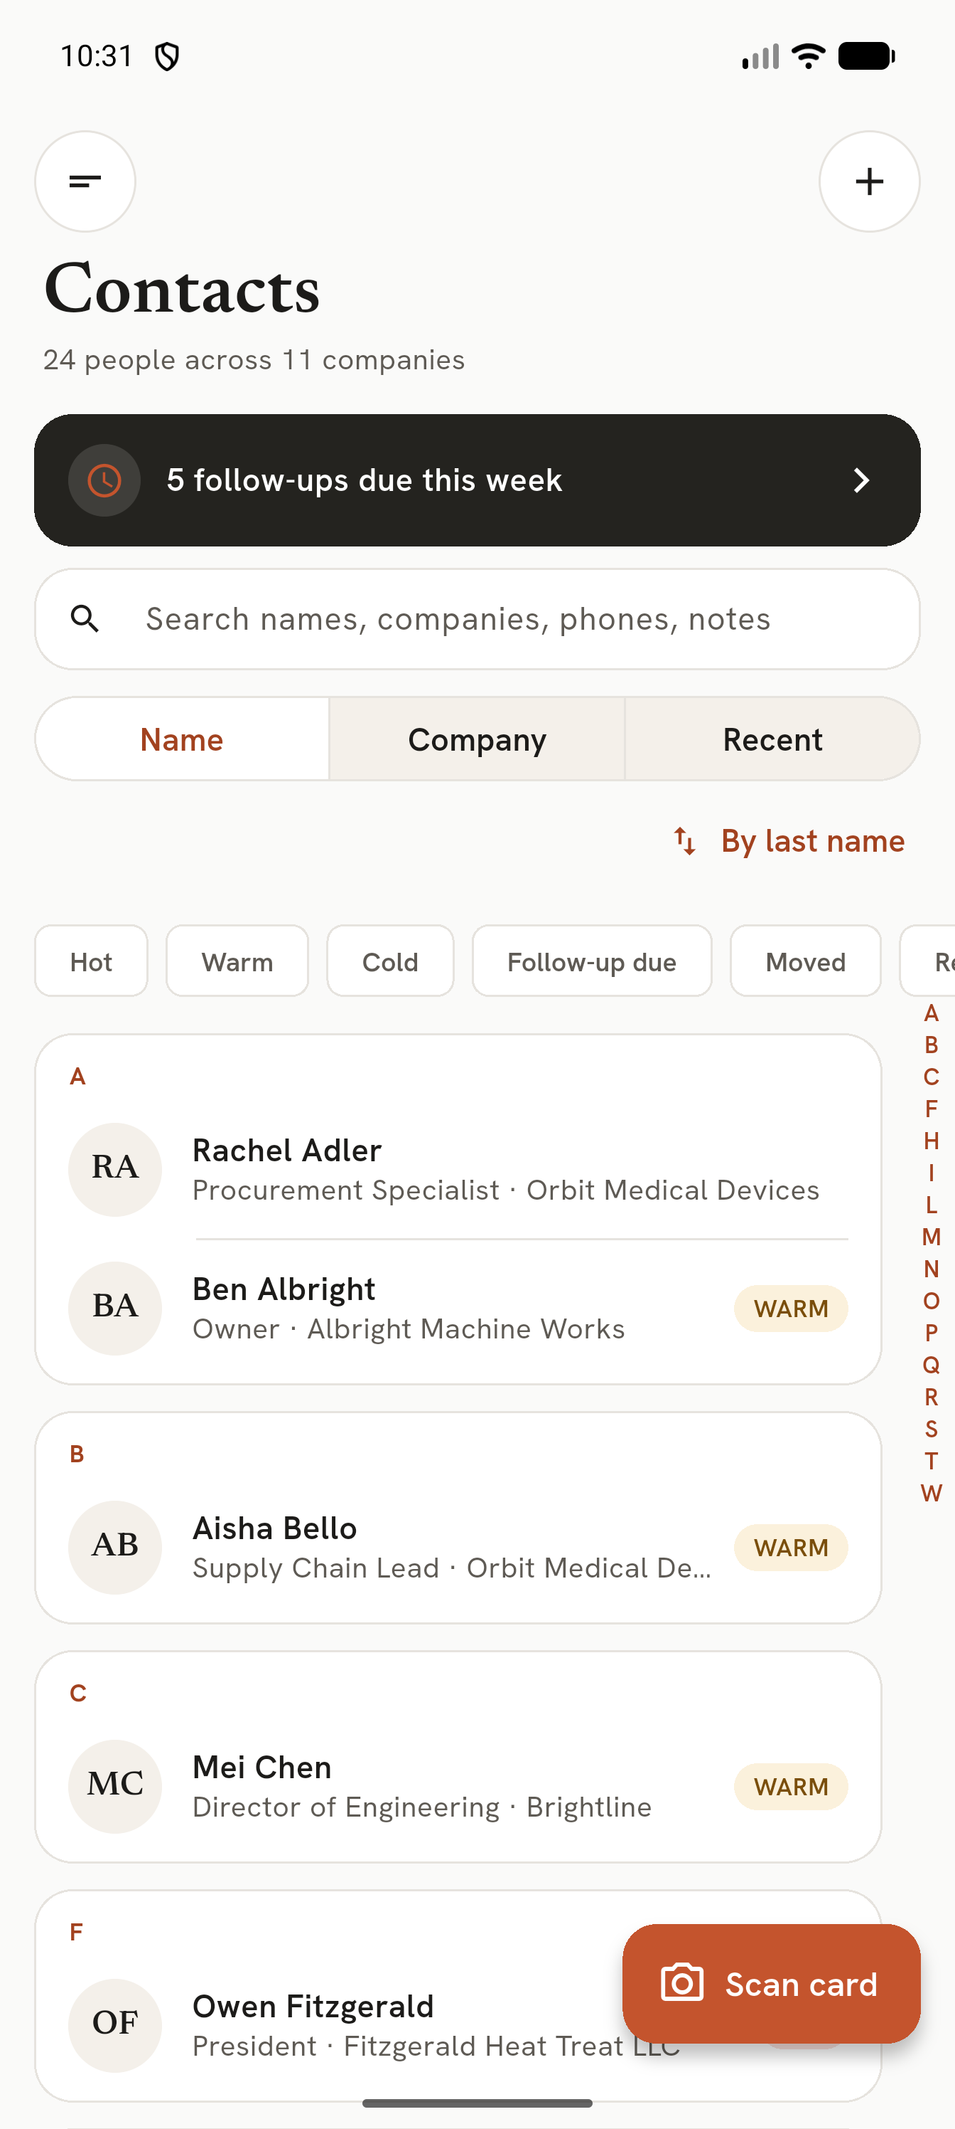
Contacts
- Search matches any part of a name, company, title, email, phone digits or notes.
- Name / Company / Recent changes the grouping. *By last name* switches to first-name sorting (also in Settings).
- Filters: Hot, Warm, Cold, Follow-up due, Moved, Retired, and your tags.
- The A–Z strip on the right jumps through the list.
- Long-press a contact to select several, then rate, tag, share as vCard or delete them.

A contact's page
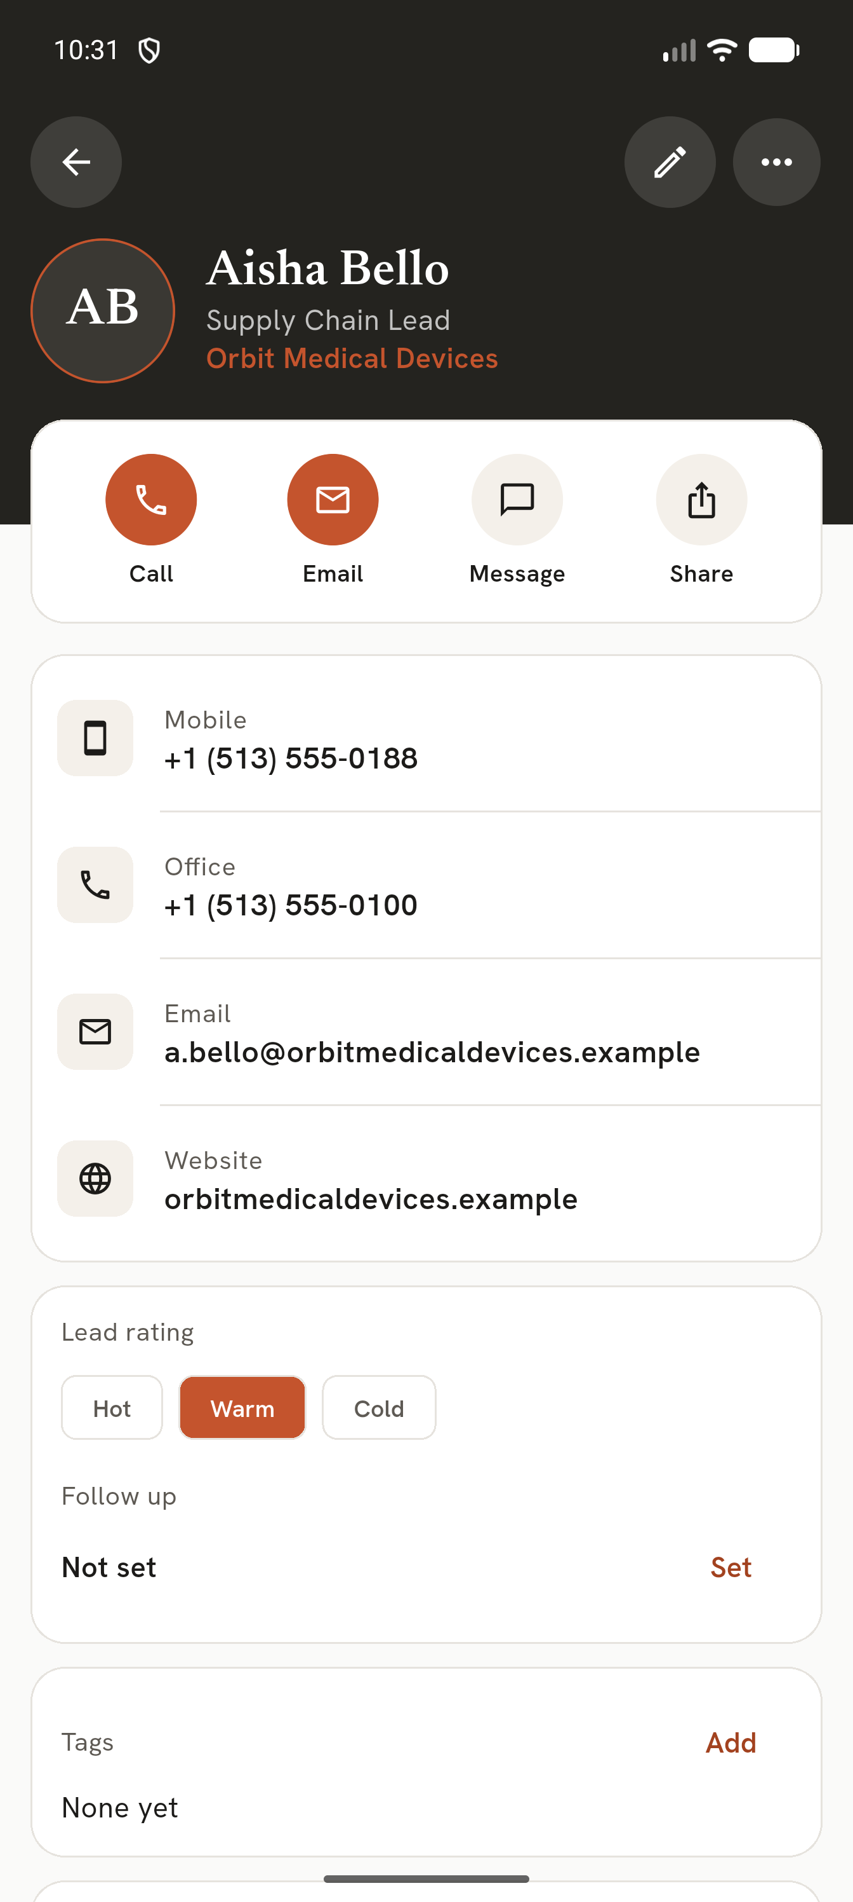
A contact
- Call, Email, Message, Share across the top. Tap any phone, email, website or address to open it in your
own apps; long-press to copy (copies are marked sensitive so Android hides them from clipboard previews).
- Lead rating Hot / Warm / Cold. It can be switched off everywhere in Settings.
- Follow up: set a date; you get a reminder that day.
- Tags, dated notes, the card (front and back, tap to zoom), Others at this company, and the
person's career history. Check on web searches for them in your browser.
- The pencil edits the contact; ⋯ has Delete, Remove logo and more.

Adding by hand
+ → Add by hand. Several phones (with a live check that the number is valid) and emails, middle name or
initial, website, address, company and title (suggested from contacts you already have), rating, follow-up, notes.

Deleting
Delete shows Undo. A deleted contact can be brought back for 7 days; after that it is wiped for good, with its
card photos and logo. Deleted contacts are never included in backups.

5. Follow-ups and reminders
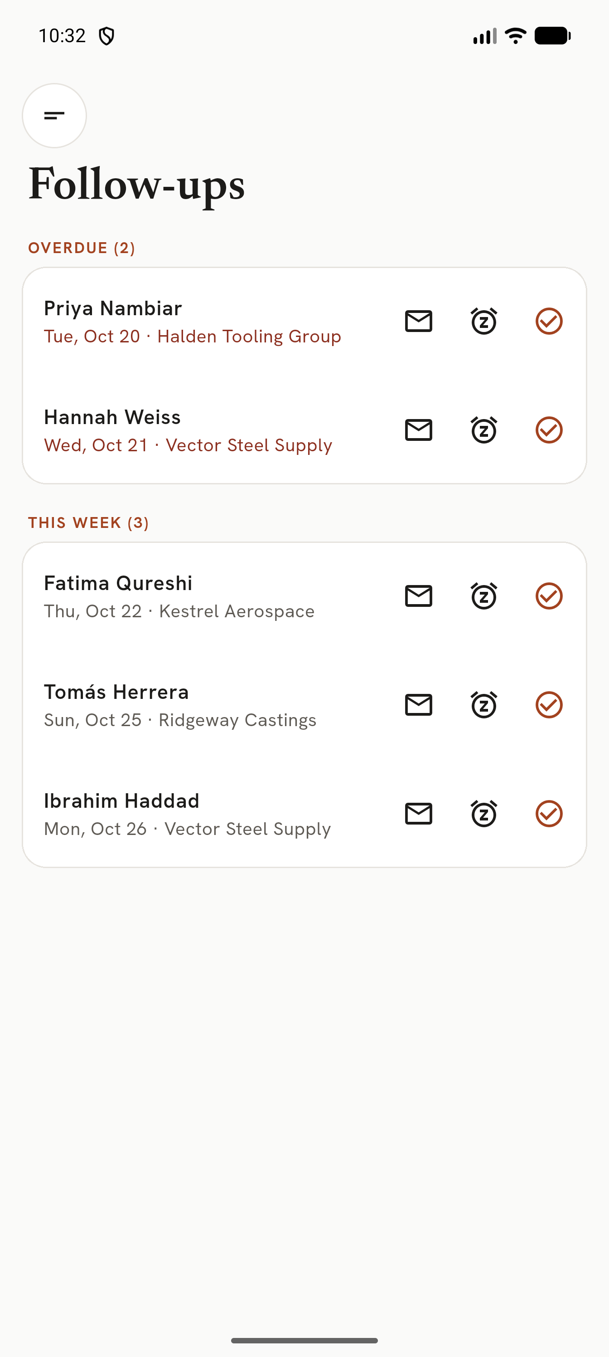
Follow-ups
Menu → Follow-ups (or the "due this week" banner on Contacts) lists Overdue, This week and Later. For each:
- Envelope: draft the follow-up email in your mail app. It is marked done only when you confirm it was sent.
- Clock: push it to tomorrow, 3 days or next week.
- Tick: mark it done.
A reminder notification arrives on the follow-up day (around 8:00); tapping it opens the contact. Android asks
once for permission. Reminders survive a phone restart. On the lock screen the reminder hides who it is about.

6. Events
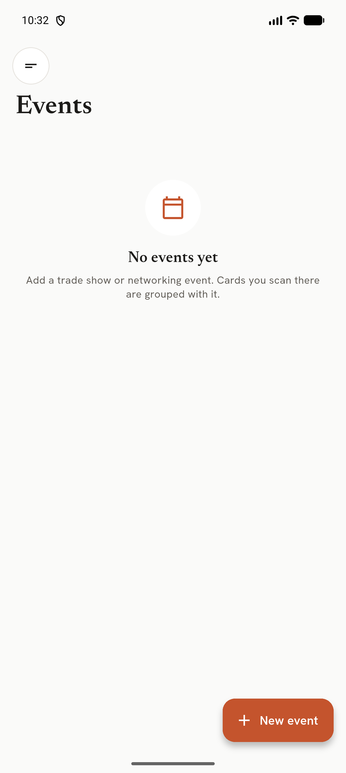
Events
Menu → Events → New event: name, dates, location, booth, a contact goal and notes.
Start scanning for this event opens a scan session: every card you scan belongs to the event and contacts saved
from it are marked *Met at*. An event page shows the goal ring, cards, contacts, companies and follow-ups.
Follow up with everyone sets a follow-up for everyone you met there. Events set to auto-start open their session
the first time you open CardKeep on an event day.

7. Tags
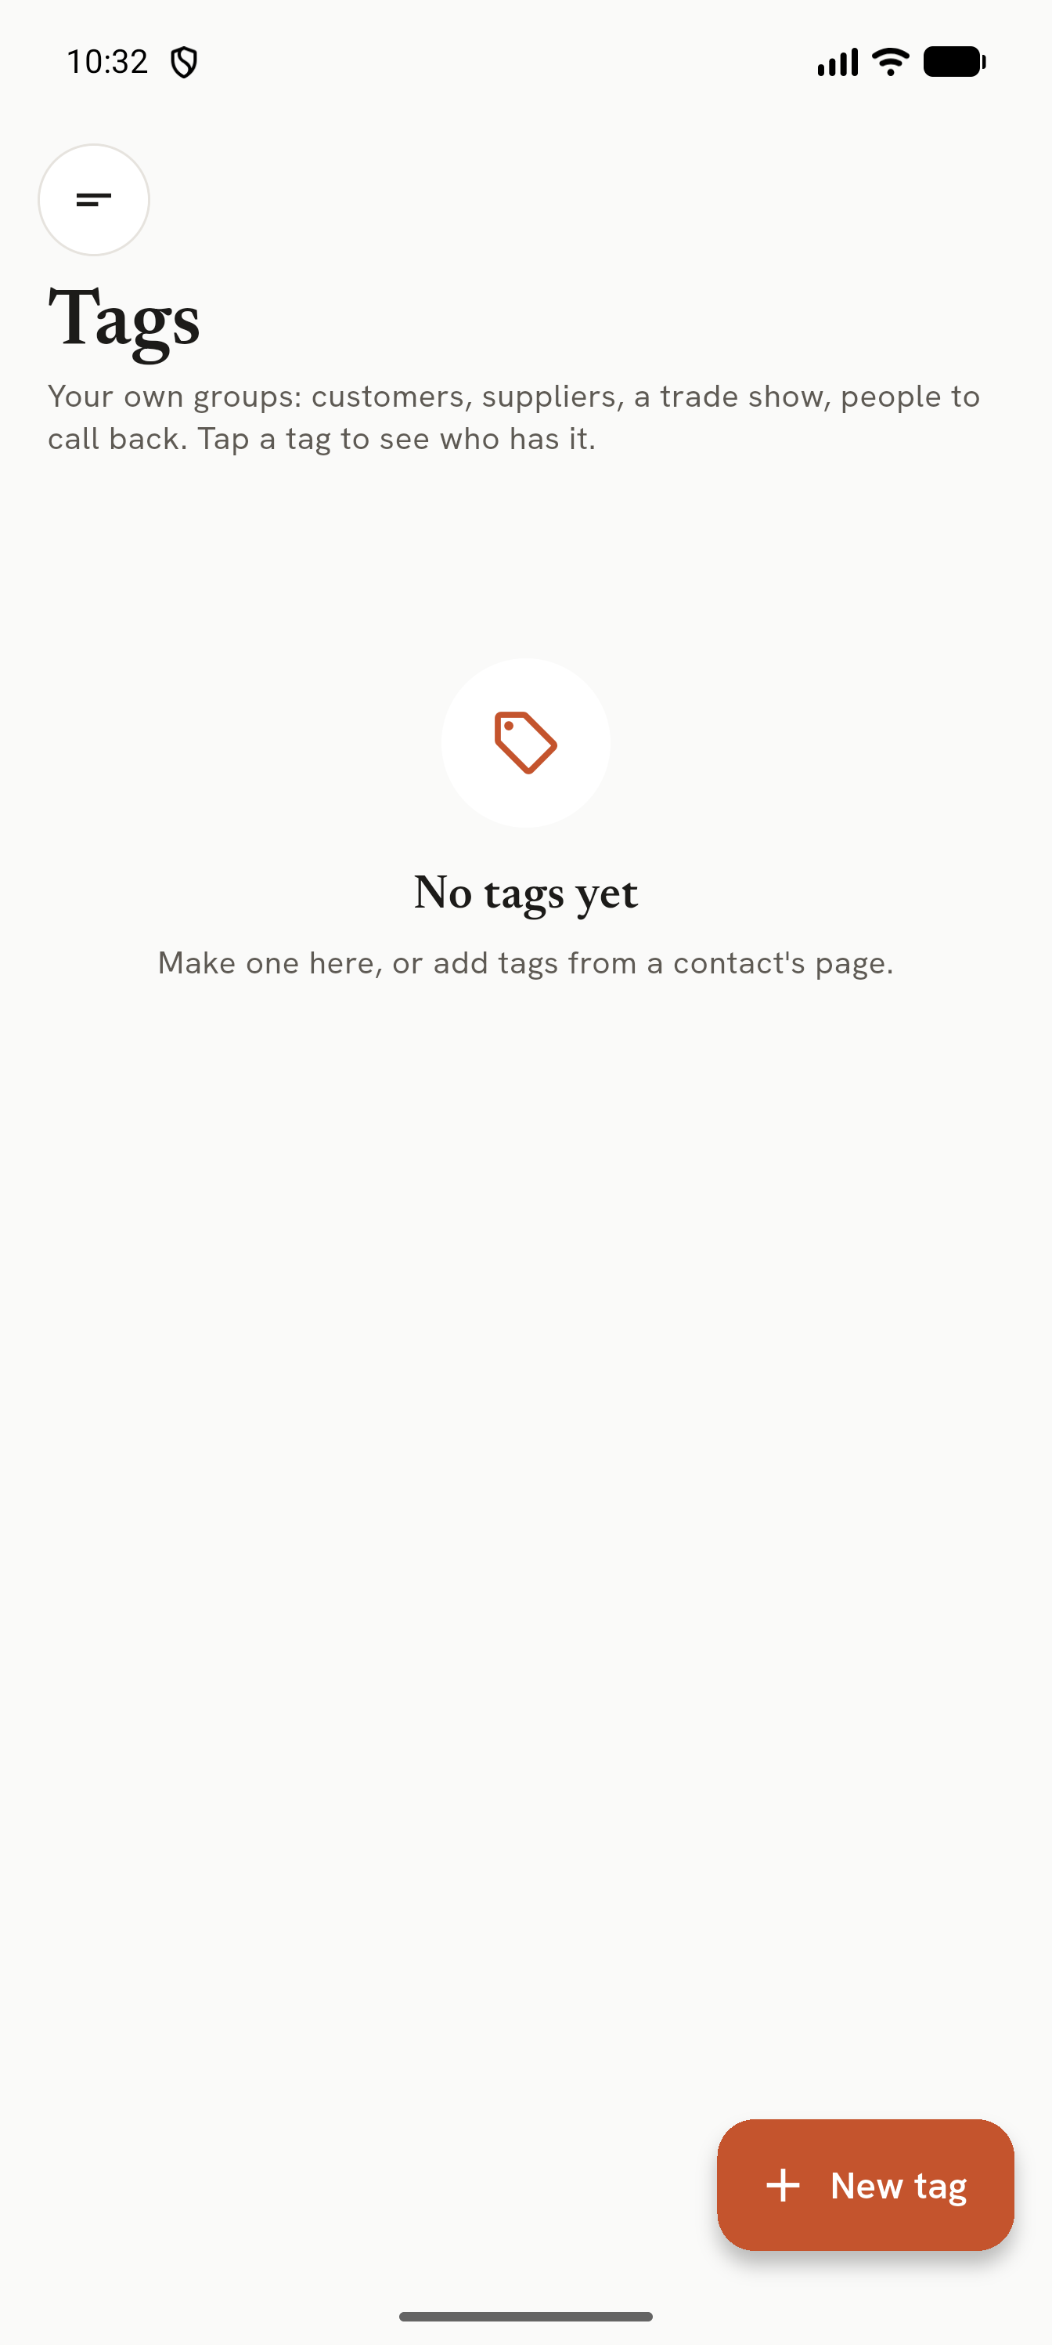
Tags
Your own groups (customers, suppliers, a trade show) with a name and colour. Create them here or from a contact's page.
Tags become filters on Contacts and are searchable. Deleting a tag asks first and says how many people have it; the
contacts stay.

8. Duplicates
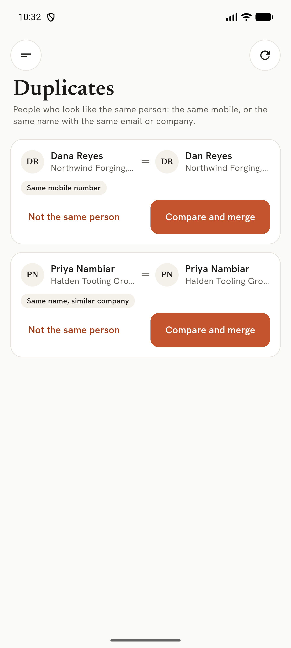
Duplicates
People who look like the same person (same mobile, or the same name with the same email or company), each with the
reason. Compare and merge lets you pick the name, title and rating per field and combines phones, emails, cards,
tags and notes. Undo merge works until CardKeep closes. Not the same person is remembered.

9. Career moves
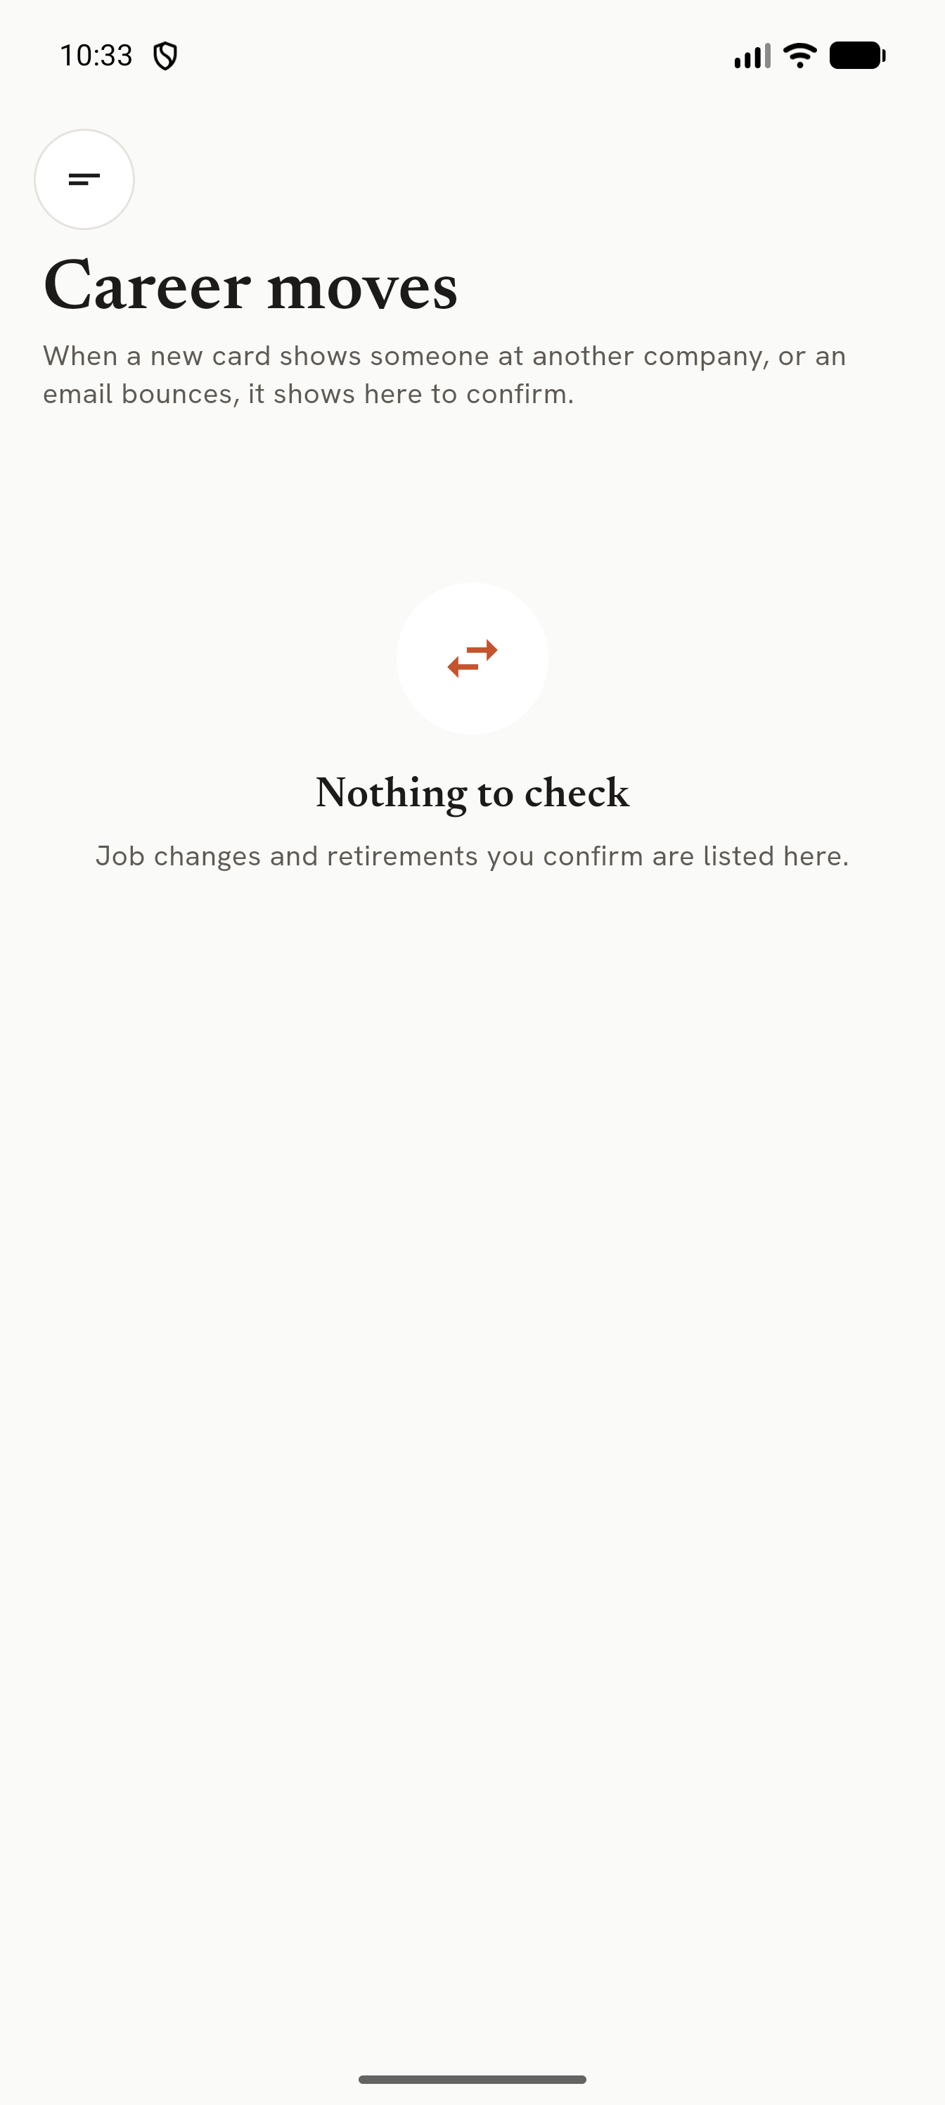
Career moves
When a new card shows someone at another company, or an email bounces, the change appears here to confirm. Confirmed
job changes keep the old role in the person's history; retirements and successors are tracked. Career tracking can be
turned off in Settings, or per contact.

10. Tap cards (NFC)
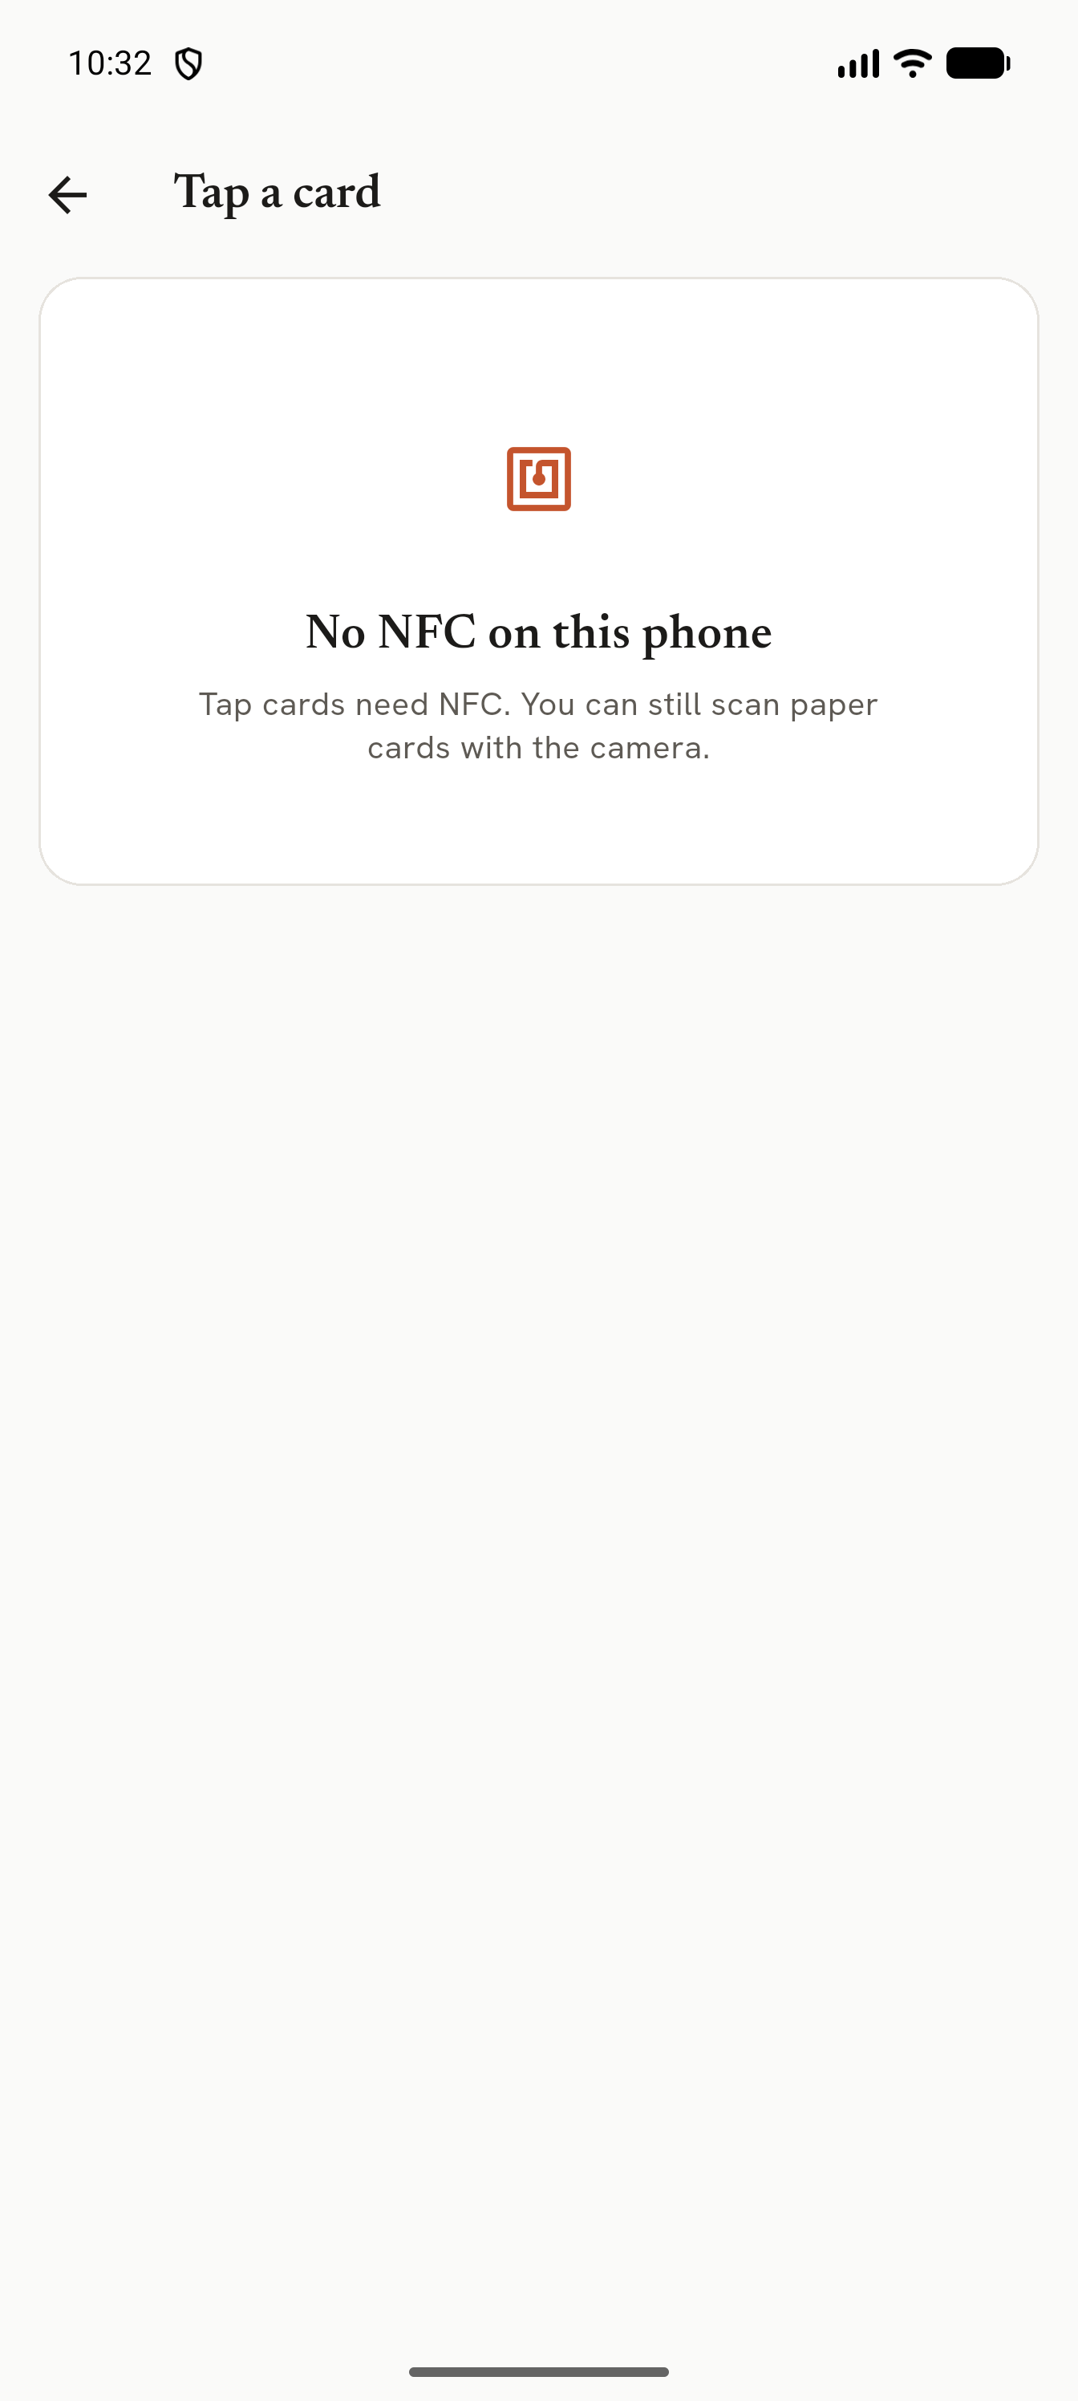
Tap cards
Menu → Tap cards (NFC). Hold an NFC business card to the back of the phone, then the next one; each gives a buzz
and a row. A contact card opens the review form; a link card can be opened in the browser or saved as a link
(tagged *NFC link*); text can be copied. The same card tapped again within 3 seconds is ignored. Payment cards and
door badges are not read. On a phone without NFC, or with NFC off, the screen says so (with a button to NFC settings).

11. My card
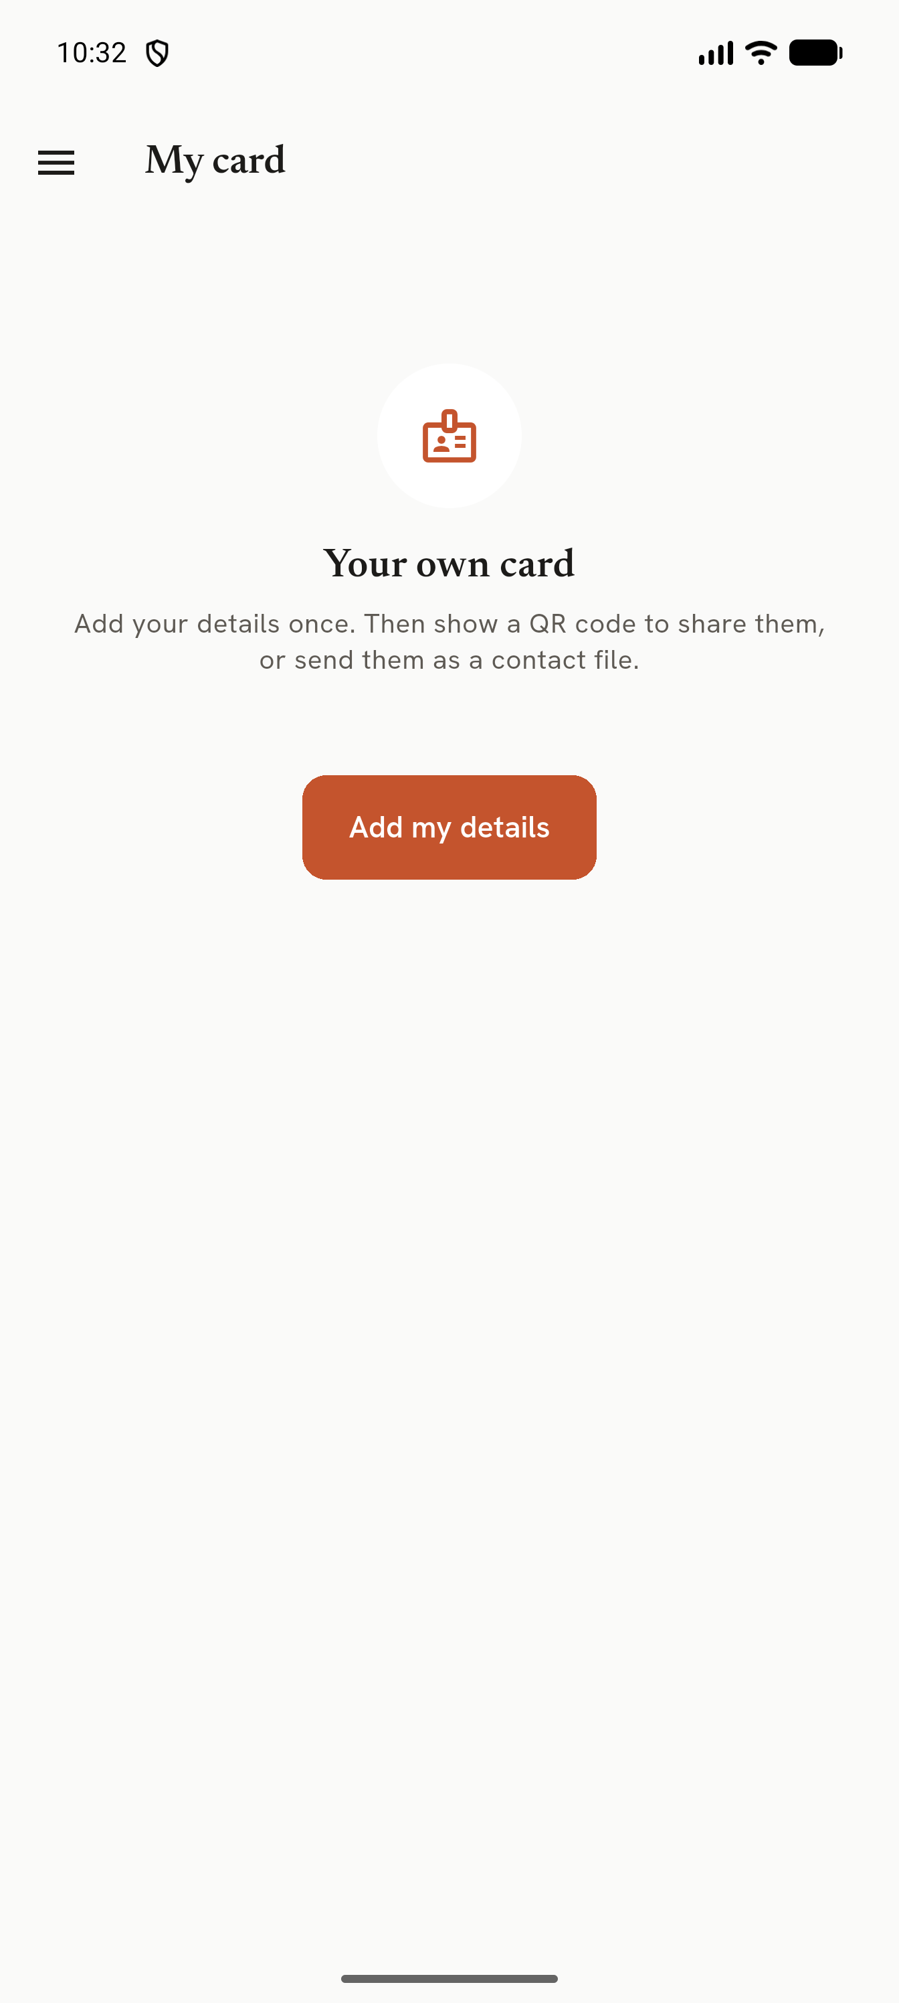
My card
Add my details once. Then show them as a QR code (tap for full screen at full brightness) for someone to scan,
or send them as a contact file.

12. Import, export, backup

Import
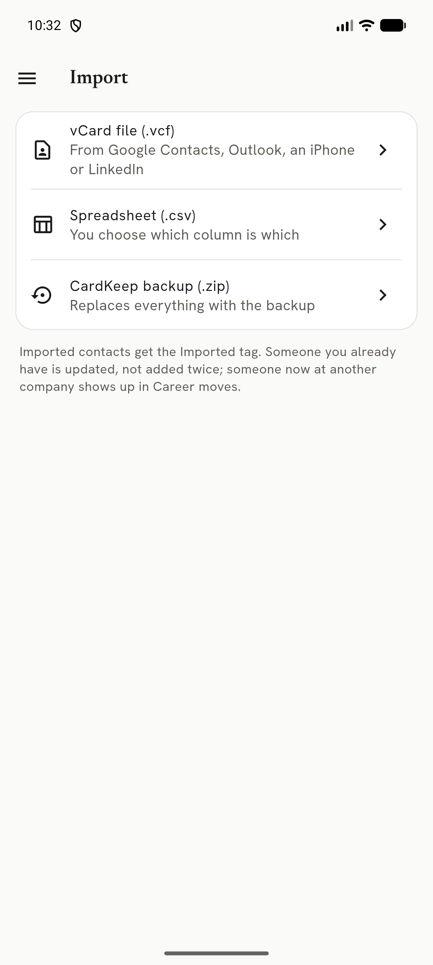
Import
- vCard file (.vcf): from Google Contacts, Outlook, an iPhone or LinkedIn. You can also open or share a .vcf from
another app straight into CardKeep.
- Spreadsheet (.csv): a column-matching screen with a preview; the matching is remembered.
- CardKeep backup (.zip): see Restore below.
Imported contacts get the Imported tag. Someone you already have is updated, not added twice; someone now at
another company shows up in Career moves.

Export
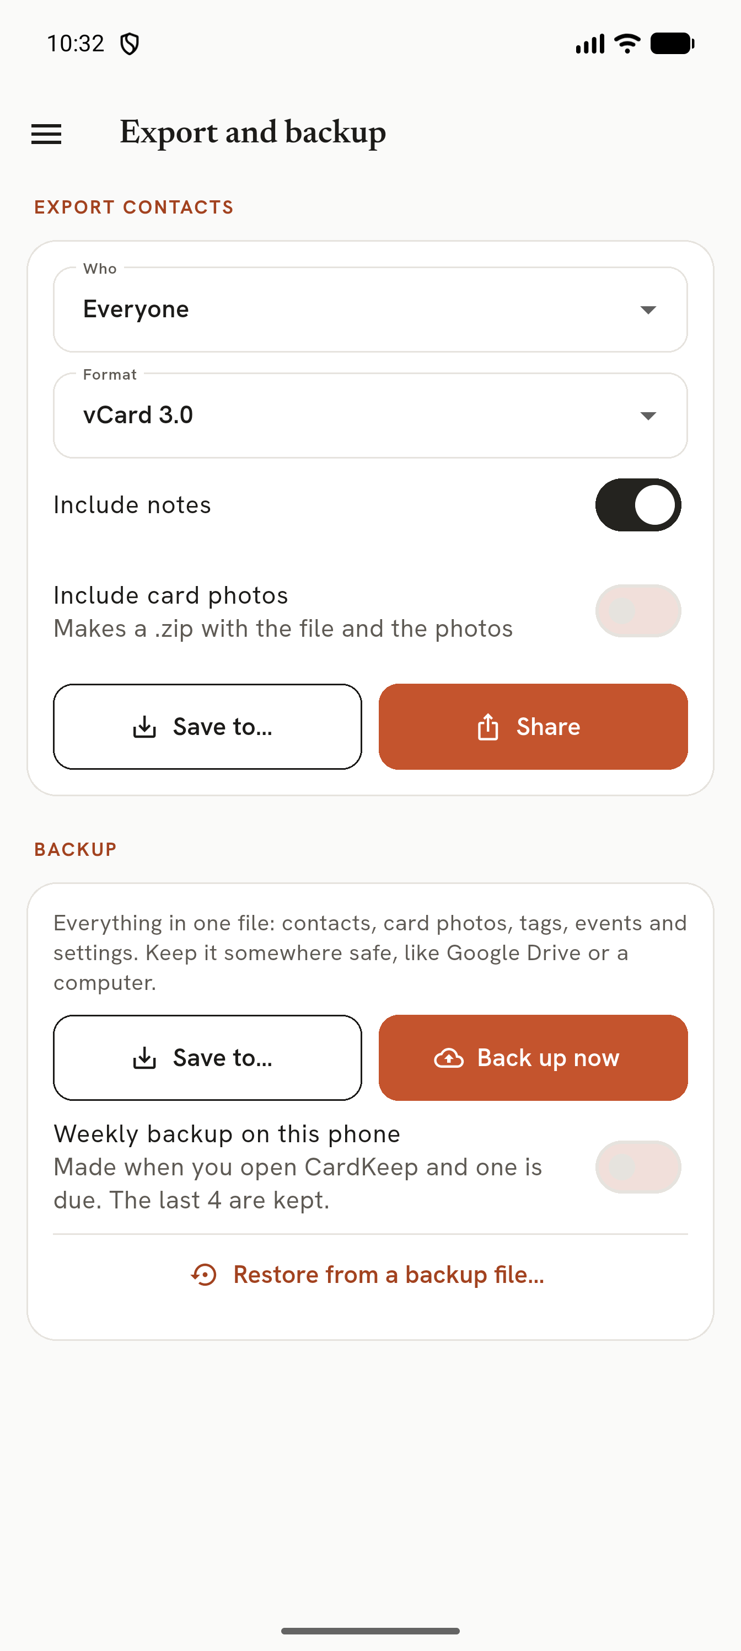
Export and backup
Choose who (everyone, a tag or an event) and the format (vCard 3.0 or 4.0, CSV, HubSpot CSV, Salesforce CSV),
with or without notes, optionally zipped with the card photos. Share it or Save to... any folder.

Backup
Back up now makes one zip with contacts, card photos, tags, events and settings. Keep it somewhere safe off the
phone (Google Drive, a computer). Weekly backup (off by default) makes one when you open CardKeep and one is due,
keeping the last 4 on the phone.
CardKeep is excluded from Android's own cloud backup and device-to-device transfer, so **your own backup zip is the
only copy**. Make one before changing phones or reinstalling.

Restore
Restore from a backup file... checks the file first: it refuses damaged files, files that are not CardKeep backups,
files from a newer CardKeep and files over 1 GB. The restore happens the next time CardKeep opens, and is safe even if
the phone turns off in the middle. Afterwards you are told whether it worked.
Your data from before the restore is kept. Data from before the last restore (in Export and backup) shows its
date and size: Go back to it swaps it back in on the next start; Discard deletes it. It is deleted
automatically after 30 days.

13. Settings
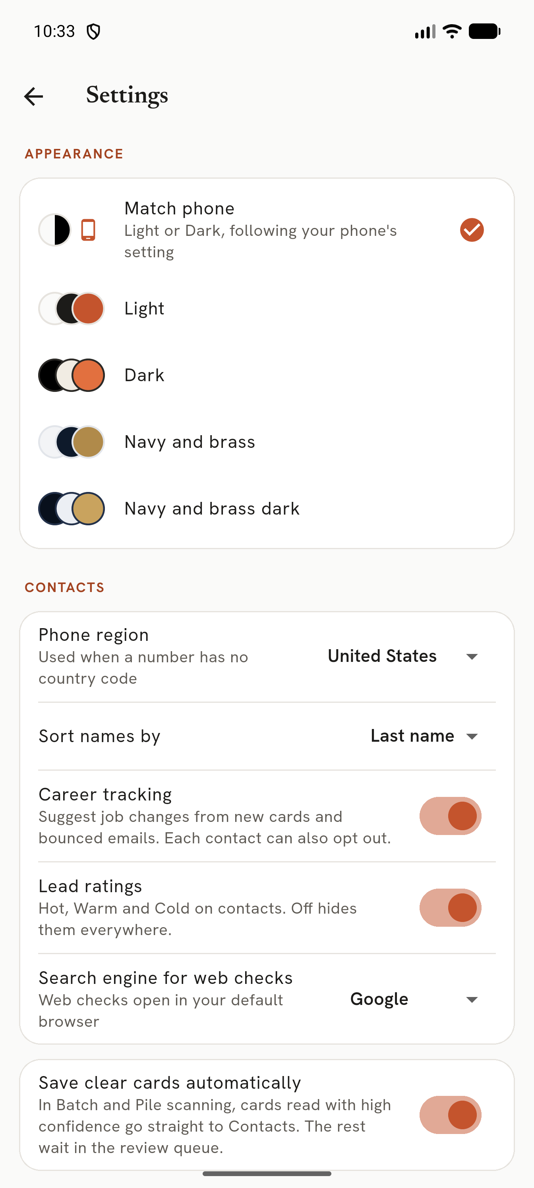
Settings
Setting | What it does | Default
Appearance | Match phone, Light, Dark, Navy and brass, Navy and brass dark | Match phone
Phone region | Country code assumed for numbers without one | Your phone's region
Sort names by | First or last name | Last name
Career tracking | Suggest job changes from new cards and bounced emails | On
Lead ratings | Hot / Warm / Cold everywhere | On
Search engine for web checks | Used by Check on web | Google
Save clear cards automatically | Batch and Pile: confident cards skip the queue | On
Hide in recent apps | Blanks CardKeep in the app switcher and blocks screenshots | Off
Updates | Check for updates; optional check at startup | Check at startup off

Updates
Settings → Updates → Check for updates asks GitHub for the latest release, shows what's new, downloads it and
installs it over the current version. Your contacts stay. The download must match the checksum GitHub publishes, or
it is refused. Offline or interrupted downloads say so and can be retried.

14. Privacy
- Contacts and card photos stay in CardKeep's private storage. Photos are saved without location or camera data.
- Cards are read on the phone; nothing is uploaded. No account, no analytics, no ads. Google's ML Kit usage logging
is switched off.
- CardKeep goes online only to check for updates when you ask (or at startup, if you turn that on). It sends nothing
about you.
- Excluded from Android cloud backup and device transfer.
- Reminders hide the contact on the lock screen; *Hide in recent apps* hides the app's screen in the app switcher.

15. Troubleshooting
Problem | Try
Scanner keeps saying *Move closer* | Fill about half the screen width with the card; put it on a plain, darker surface.
A field is wrong after scanning | On review, tap the right line of text and pick the field, or use Read a region.
Edges not found | Adjust corners, or photograph the card on a contrasting surface.
Dark or glossy card reads badly | Tilt slightly to remove glare; turn on the torch; dark cards get a second pass automatically.
No reminder arrived | Allow notifications for CardKeep in Android settings; check battery optimisation isn't stopping it.
"Reading N cards left from last time" | Normal after closing mid-scan; the cards land in the Review queue.
Update download failed | Check the connection and tap Check for updates again.
Restore was refused | The file is damaged, not a CardKeep backup, from a newer CardKeep, or over 1 GB.
Tap cards says no NFC | The phone has no NFC, or it is off: use the button to NFC settings.

